Mr. Visca – AP Calculus AB

Unit 4: Applications of derivatives Review Notes

**Extreme Values**

The _____________ and ______________ of the function. On the graph, they are the

____________________ and _________________.

Find Extreme values algebraically by: __________________________________

These are called: ________________________________

Ex. Find the mins and maxes, and where they occur of the following function,

$y=\frac{1}{3}x^{3}+6x^{2}+27x$

**Mean Value Theorem for Derivatives**

🡪 If f(x) is differentiable on the interval [a,b], then there exists a point “c”

where __________________________________________________

Show that the function f(x) = x2 satisfies the hypothesis of the mean value theorem on the interval [0,2].

**Graphs: f’(x) is slope & f’’(x) is concavity**

***First Derivative*** indicates ________________ of graph of original function

_________________ is negative (downward) when f ’(x) < 0; or when f ‘ (x) is negative

_________________ is positive (upward) when f ’(x) > 0; or when f ‘ (x) is positive

_________________ changes at from positive to negative or negative to positive at CRITICAL POINTS; this is where f ‘ (x) __________________________________

***Second Derivative*** indicates ________________ of graph of original function

_________________ is negative (frown face) when f “(x) < 0; or when f “ (x) is negative

_________________ is positive (smiling face) when f “(x) > 0; or when f “ (x) is positive

_________________ changes at from positive to negative or negative to positive at INFLECTIONS POINTS; this is where f “ (x) __________________________________

Find any extreme values, points of inflection, and sketch the graph of y = x3 - 3x2 + 4.

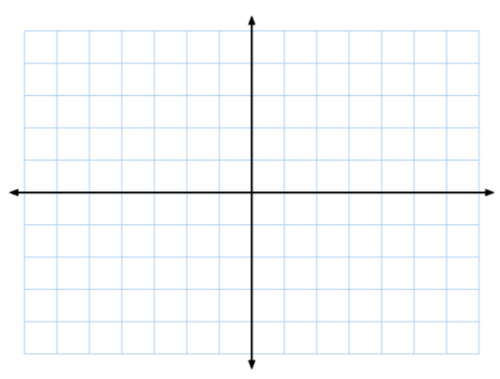

**Related Rates:**

Dimensions or measurements that are changing with respect to time: a change in radius, height, etc…

The radius of a sphere is decreasing at a rate of 0.5 cm/sec. What is the rate of change of its volume when r = 20?

A 10-foot ladder leans against a vertical wall. The base of the ladder is pulled away from the wall at a constant rate of 2 ft/sec. At what rate is the top of the ladder falling when the base of the ladder is 8 feet from the wall?

Unit 4 REVIEW Practice Problems

Show all your work! Allowed to use a calculator with any problem with an “*”

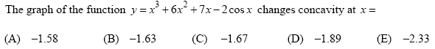*1.



2.

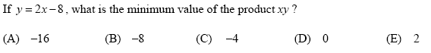3.

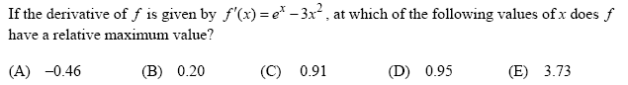*4.

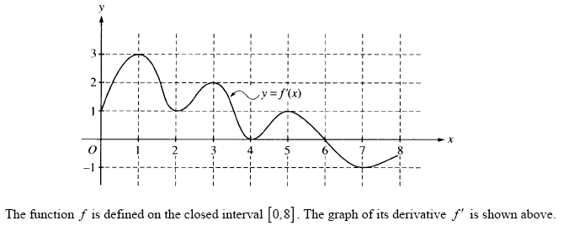5.

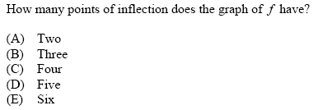

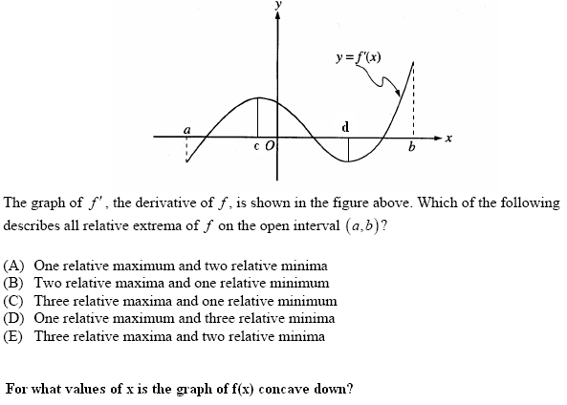6 – 7.

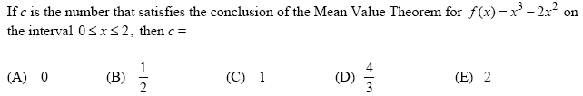8.

9. A particle moves along a line with position *x*(*t*) = 2*t*3 -10*t*2 + 14*t* – 11, *t* ≥ 0. During which

interval(s) is the particle moving to the left?

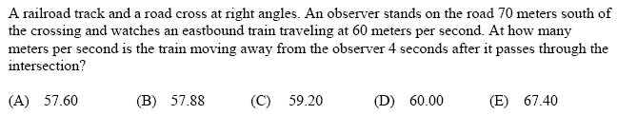10.

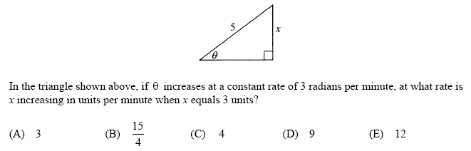11.